Katharine LoScalzo

Caitlin Morris

Creative Coding

5 December 2016

Final Project Proposal

**Description:** For my final project, I will be creating a music video to the Beatles’ song, “Blackbird”. The video will follow a lone blackbird in its journey of learning to fly. Other characters include the blackbird’s mother and white birds. The tone of the short will be sad, yet hopeful, and eventually inspiring. **\*\*sketch below**

**References:** One inspiration I took in the formation of this idea was from the “Angry Birds” movie. In the animation, the comical birds experienced a wide variety of emotions; in my project, I will try to convey sadness, happiness, and anger. Another inspiration was Pixar’s “Lava” short, in which a volcano sings about its desire for a companion. Like my project, the song plays a huge role in the video, and sadness and joy are keys to its great impact. And similar to the unhappy volcano who desires a mate, my unhappy blackbird desires to fly. Through desire and other human emotions, the characters in “Lava” and in my short are personified. **\*\*references below**

**Technology:** I plan for my project to be based in p5.js. However, I will continue to look at Processing to compare the two and decide which is ultimately a better option for my project.

**Setup:** I plan to show my final off of a projector, so I will have to pay special attention to my color scheme to make sure all characters and objects show up clearly.

**Components:** Regarding familiarity**,** I am pretty comfortable with shapes, colors, images, and sound, major components of my project.

**Challenges:** While I understand how to move objects, specific directions and motion as a whole may prove complicated. Additionally, aligning the short’s motion with the speed and lyrics of the song may be challenging.

**Calendar:** By 12.8, I plan to have created my project’s characters and imported audio. For the 12.13 checkpoint, I plan to have created six of my nine scenes, and have them aligned properly with the music. If I need more materials or resources, I will ensure all my research is completed by 12.9 so that I know how to do what needs to be accomplished.

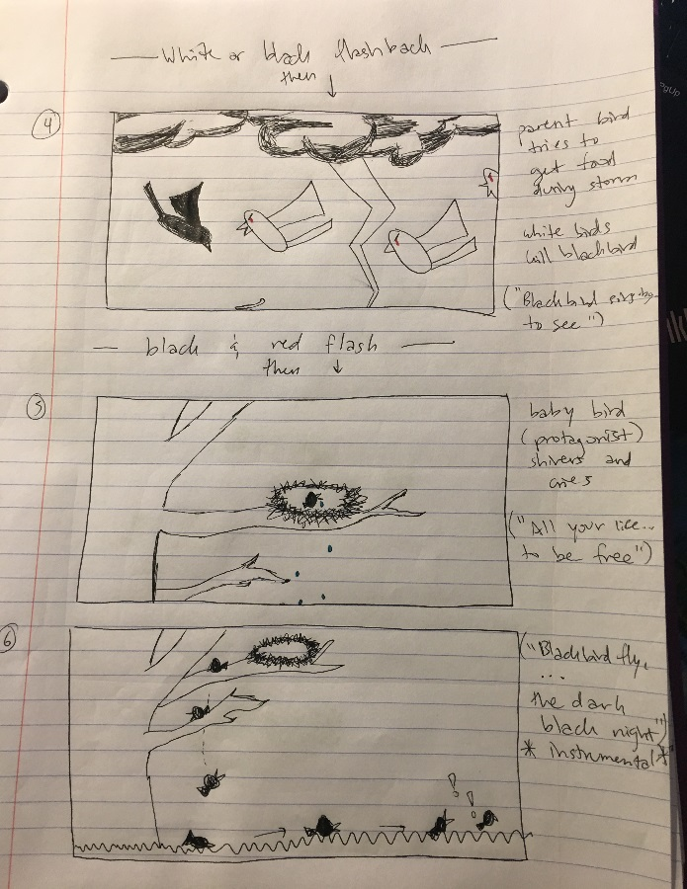**Sketch:**

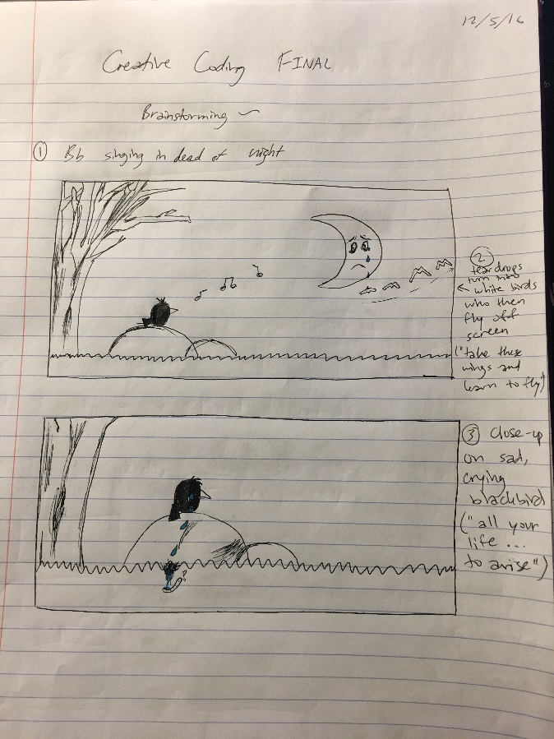

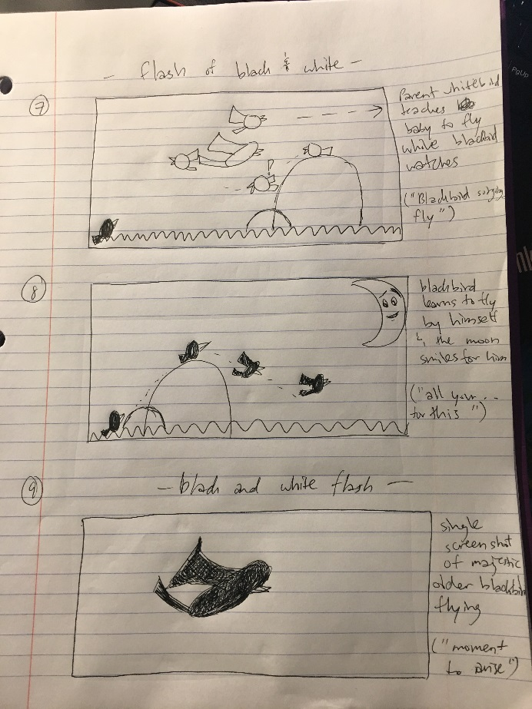

**Resources:**

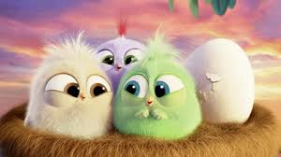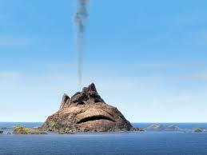

“Angry Birds” “Lava”